Task 1 – Scientific Naming – Classification Worksheet for PPT


A scientific name is a name that describes the ________________________ of an organism or
________________ it was first _____________________.
A _________________ system is used by scientists to name specific organisms.
A binomial name has _________________________. The name is wriiten with the first name having
a _________________ __________________. The second name begins with a ______________
____________ letter. The scientific name is either ___________________ or written in
_________________.

The first name given tells us the _____________________ to which the organisms belongs. This
category groups organisms with_________________________________. The species name is
________ _________________ specific category and distinguishes the organism from
________________________________________________.
Species names are unique.
The name is written with the first name having a _________________ __________________. The second name
begins with a ______________ ____________ letter. The scientific name is either ___________________ or
written in _________________.
Write the order of classification steps from largest through to smallest. Beside each step/group classification write the name to which humans belong.

The Classification of Humans:

Choose and list three organisms from the guided practice slides and correctly write their scientific names below:

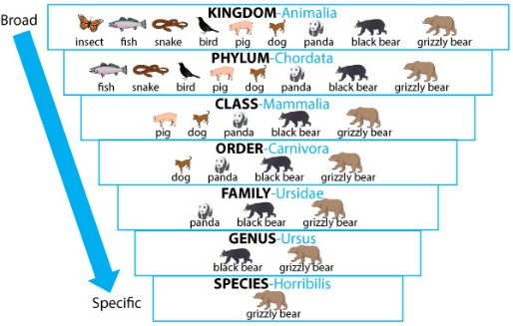

Explain the reasons why organisms are scientifically named :

Your turn: Scientific Names Hunt
Common name | Scientific name
e.g. common starfish | Asterias rubens


